🧠 🔄 COMPLETE REAL FLOW (UNDERSTAND FIRST)
Create Barcode → Insert Same ID in DB → Scan → Match → Action

👉 VERY IMPORTANT RULE:
Barcode value MUST match database ID exactly

📌 1. HOW TO GENERATE BARCODE (STEP-BY-STEP)
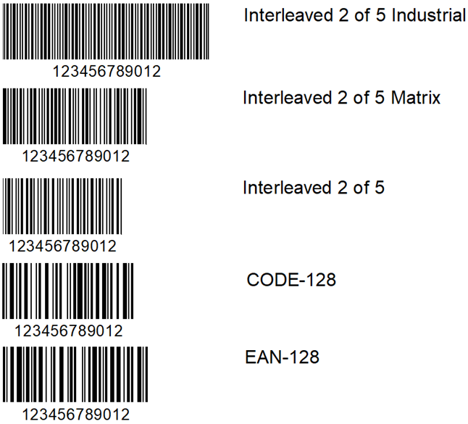
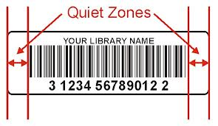

🔹 OPTION 1: Online (EASY)
Use:
👉 Barcode Generator

Steps:
- Open website
- Select:
  - Type → Code128 (best for your project)
- Enter value:
B001

- Click Generate
- Download image
- Print it

🔹 For USERS
U001
U002

🔴 IMPORTANT RULE
Thing | Example
Book Barcode | B001
User Barcode | U001
👉 SAME value must be in database

🗄️ 2. CREATE DATABASE (FROM ZERO AGAIN)

🔹 Step 1: Open MySQL
sudo mysql -u root -p

🔹 Step 2: Create DB
CREATE DATABASE library_db;
USE library_db;

🔹 Step 3: Create Tables (FINAL CORRECT)
CREATE TABLE users (
id VARCHAR(50) PRIMARY KEY,
name VARCHAR(100)
);

CREATE TABLE books (
id VARCHAR(50) PRIMARY KEY,
name VARCHAR(100),
available BOOLEAN DEFAULT TRUE
);

CREATE TABLE transactions (
id INT AUTO_INCREMENT PRIMARY KEY,
user_id VARCHAR(50),
book_id VARCHAR(50),
issue_date DATETIME,
return_date DATETIME,
fine FLOAT DEFAULT 0
);

📥 3. INSERT DATA (VERY CLEAR)

🔹 Insert Users
INSERT INTO users VALUES ('U001','Atharv');
INSERT INTO users VALUES ('U002','Rahul');

🔹 Insert Books
INSERT INTO books VALUES ('B001','Python Book',1);
INSERT INTO books VALUES ('B002','DSA Book',1);

🔍 VERIFY
SELECT * FROM users;
SELECT * FROM books;

🔗 4. HOW DATABASE CONNECTS TO MAIN CODE

🔹 Create file: database.py
import mysql.connector

def connect_db():
return mysql.connector.connect(
host="localhost",
user="root",
password="YOUR_PASSWORD",
database="library_db"
)

📷 5. HOW BARCODE CONNECTS TO DATABASE

🔹 Scanner returns:
barcode_data = "B001"

🔹 Then main code checks:
cursor.execute("SELECT * FROM books WHERE id=%s", (barcode_data,))

🔴 IMPORTANT LOGIC
Barcode | Query | Result
B001 | SELECT book | Found
U001 | SELECT user | Found

📁 6. FINAL FILE STRUCTURE (VERY IMPORTANT)
library_system/
│
├── main.py ⭐ MAIN FILE
├── database.py ⭐ DB connection
├── scanner.py Barcode scan
├── lcd.py LCD display
├── sensors.py IR sensors
├── admin_panel.py GUI

🔗 7. HOW FILES CONNECT (IMPORTANT)

🔹 Inside main.py
from database import connect_db
from scanner import scan_barcode
from lcd import lcd_display
from sensors import detect_mode

👉 This is how modules connect

🧠 8. MAIN EXECUTION FLOW (REAL)

🔹 Step-by-step
- Run:
python3 main.py

- LCD shows:
Select Mode

- IR Sensor Trigger
👉 ISSUE / RETURN selected

- Scan Book
👉 Barcode → "B001"

- System checks DB
SELECT * FROM books WHERE id='B001';

- Scan User
👉 "U001"

- System processes:
- Issue → update DB
- Return → calculate fine

⚠️ 9. MOST IMPORTANT THINGS TO REMEMBER

🔴 1. Barcode = Database ID
👉 MUST match EXACTLY

🔴 2. File Names Matter
File | Purpose
main.py | Main system
database.py | DB connect
scanner.py | Scan

🔴 3. Database Name MUST match
database="library_db"

🔴 4. Table Names MUST match
users
books
transactions

🔴 5. Column Names MUST match
id, name, available

🔴 6. Password MUST be correct

🧪 10. FULL TEST (REAL SCENARIO)

🔹 You scan:
Book → B001
User → U001

🔹 System does:
SELECT * FROM books WHERE id='B001';

✔ Found

UPDATE books SET available=0

🔹 Output:
Issued Successfully

